Students may use their text book, any hand written notes, and any digital notes or programs written by the student (You may use your flash drive). **DO NOT USE THE INTERNET** 8:00am – 11:00am

**SHORT ANSWER SECTION**

1. (10 Points) a) Briefly, describe how variables operate in java.

b) Before a variable can be given a value / or number value what does the programmer have to do to/with the variable?

Programmer can declare or initial them.

2. (10 points) a) Describe the difference between an **integer(int)** number type and **double** number type in java.

Int use to store whole number such 1, 2, -1, -3 while double has the capacity to use the decimals

b) If a java program was returning an **integer(int)** number type for the following equation

2 / 3 = , what would be the answer and why?

The answer is 0 because the int type is not a double, so it couldn’t output the decimals or fractional digit and by default, It returns 0

3. (10 Points) a) (10 Points) How does the ASCII standard control the execution of the java method? *stringname1.***compareTo**(*stringname2*)

ASCII stand for American Standard Code for information interchange. The standard 8-bit ASCII character set is a subset of Unicode and rages from 0 to 127. Thus, the ASCII characters are still valid java characters.

There are two variants of this method. First method compares this String to another Object and second method compares two strings lexicographically.

4. (10 Points) – a) Describe how the term **null** is used in java.

the zero-valued ASCII character, also designated by NUL, often used as a terminator, separator or filler

b) String inputString = JOptionPane.showInputDialog(**null**, "Enter an Number", "Input Dialog Box Demo", JOptionPane.INFORMATION_MESSAGE);

In the method above for creating an input “pop up box,” what is the purpose of **null?**

It is a component parent that specifies the component relative to which the dialog is displayed. If you pass null for this argument, the dialog is usually displayed in the center of the screen.

**SHORT ANSWER SECTION Cont…**

5. a) (10 points)

**Complete Logic Table**

|  |  |  |  |  |  |  |
| --- | --- | --- | --- | --- | --- | --- |
| **P** | **S** | **P &S** | **P | S** | **P ^ S** | **!S** | **(P&S) ^ (P|S)** |
| **FALSE** | **TRUE** | **False** | **True** | **False** | **False** | **False** |
| **FALSE** | **FALSE** | **False** | **False** | **True** | **True** | **True** |
| **TRUE** | **FALSE** | **False** | **True** | **False** | **True** | **False** |
| **TRUE** | **TRUE** | **True** | **True** | **False** | **False** | **False** |

**BASIC SYNTAX ERRORS:** (10 Points – 2 Points Each) Spot the basic Syntax errors

1) System.out.println(“Print your name);

It misses the “

Correct:

System.out.println(“Print your name”);

2) public class Constructor {

public static void main(String[] args) {

System.outprintln();

}

It misses the . between out and println();

Correct:

) public class Constructor {

public static void main(String[] args) {

System.out.println();

}

3) **int** a;

**int** = 0

it misses the a

and it declares the variable twice

Correct:

Int a = 0;

Or

Int a;

Int b = 0;

4) Public static void main(String[] args)

It has capital p at public and no bracket

Correct: public static void main(String[] args) {

}

5) **int** b;

b = 1.5;

b is an integer but it assigns a double(decimal) in to an integer

**SHORT PROGRAMMING TASKS:**

(15 points) TASK 1: Create a program that allows the user to input 7 days of the week which will be stored in an Array[] of strings, and the corresponding temperature for each day which will be stored in an Array[] of doubles. Prompt the user before she enters each new day and temperature.

Output the day and corresponding temperature entered in a println output.

Output warmest temperature and coldest temperature.

Attach Snipping photos of output and source code.

**Sample Output**

Enter Day:

“Tuesday”

Enter Temperature:

“98”

Etc..

**Println Output**

Tuesday was 98 Degrees

etc…..

Warmest day of the week was Tuesday at 98 degrees.

Coldest day was Friday 22 degrees.

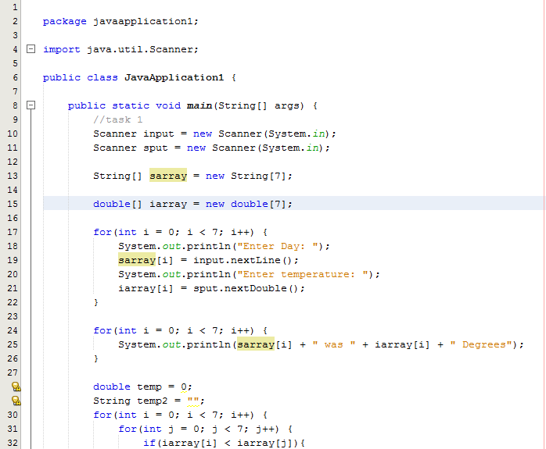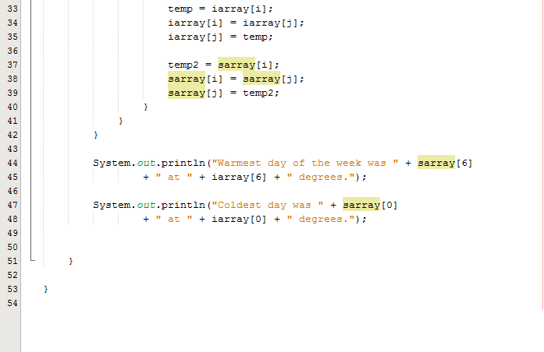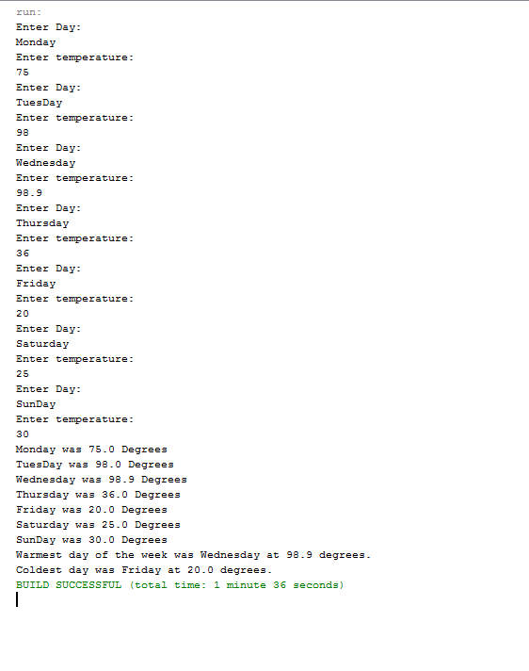

(30 points) TASK 2: Use differentloops to **print the odd / negative numbers 1 to 101. -1 to -101** All programs will print the same output in the same order.

1. Using a **for** loop that increments the loop control variable by 2 each iteration
2. Using a **for** loop whose loop control variable goes from 0 to 50.
3. Using a **for** loop whose loop contr8ol variable goes from 100 down to 0.
4. Using an infinite **for** loop with no conditional expression and exiting the loop with a **break** statement.
5. Using a **while** loop.
6. Using a **do-while** loop.

There should be 6 different Snipping photos. One photo for each program A – F.

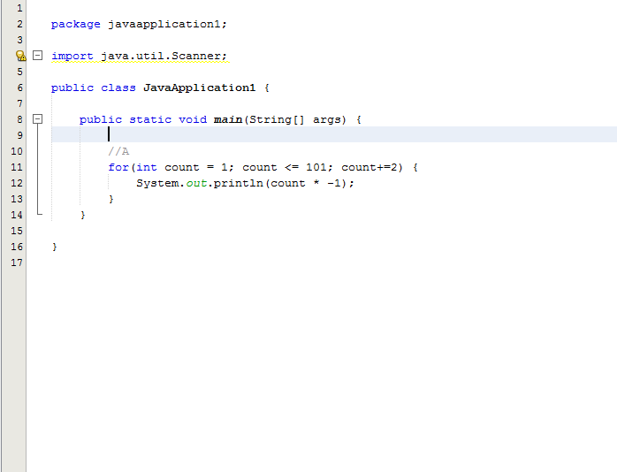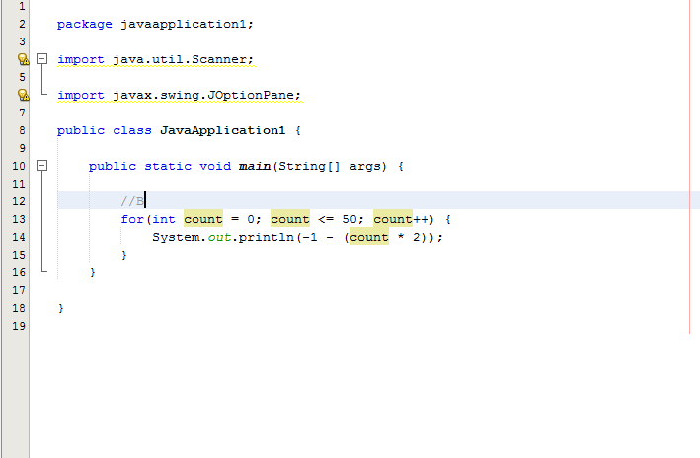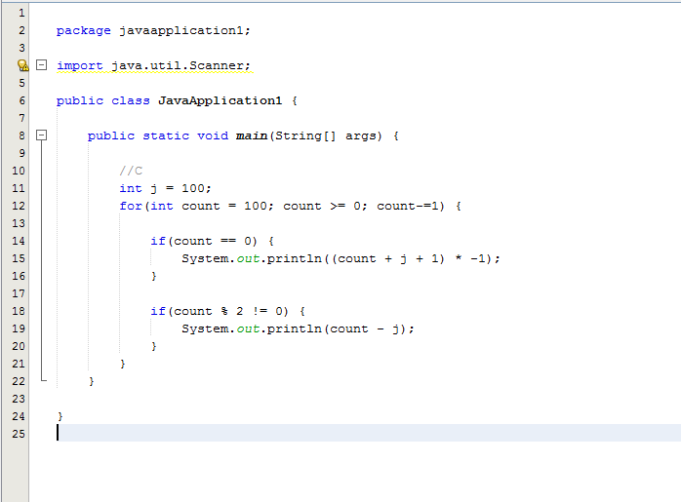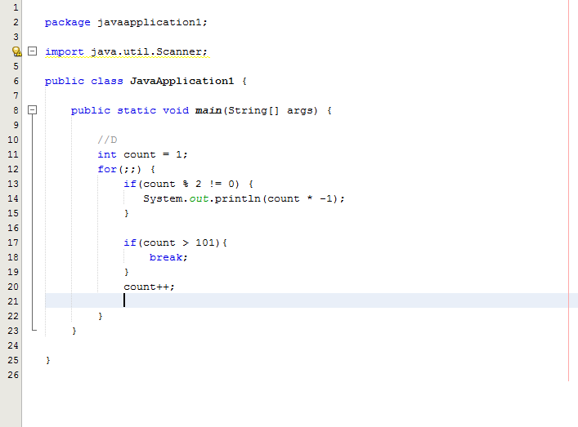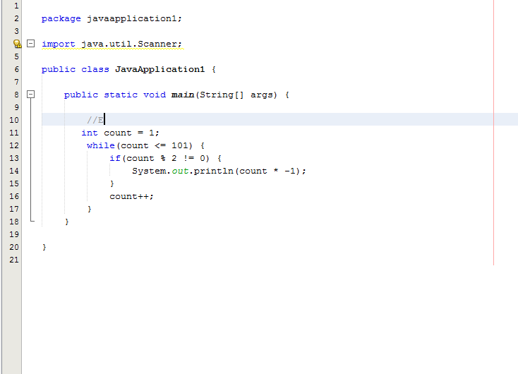

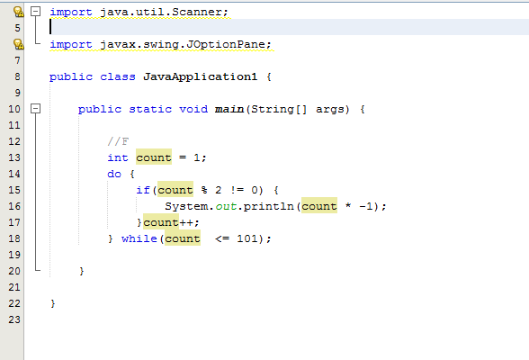

(15 points) TASK 3: Create a program that uses a **switch** **case** statements to return the number of days in any given month based upon a users input. Use a string variable to operate **switch case** control statements.

Use the **new** Scanner (System.in); method for input of Strings. Make sure the program can deal with any String input. If an input does not correspond to a month of the year print “Invalid Month.”

*variable* = input.next() {Method for string input using Scanner

February is a unique month. So the **case** for February will needa **if**… **else** to capture the two possible options for the number of days in February based upon leap year.

**{Method for calculating leap year using Boolean}**

**boolean** leapyear = (year % 4 == 0 && year % 100 != 0)

(year % 400 = 0)

Attach Snipping photos of output and source code.

